**Manual sign shipment documents with QR code**

At companyname we use software to sign shipment documents digitally and we can also add photos as a proof of delivery.

This helps us to improve our internal processes but also our professionality to our client by:

* Documenting with photo’s
* Fast proof of delivery by e-mail to customer, companyname and shipping company
* Speed up invoicing process

You can recognize a shipment that needs to be signed digitally to a QR code on the document.

It’s very simple:

1. Open the app on you phone to make a photo
2. Scan the QR code on the document and click on the link* which shows in the screen
3. Now follow the questions on the phone

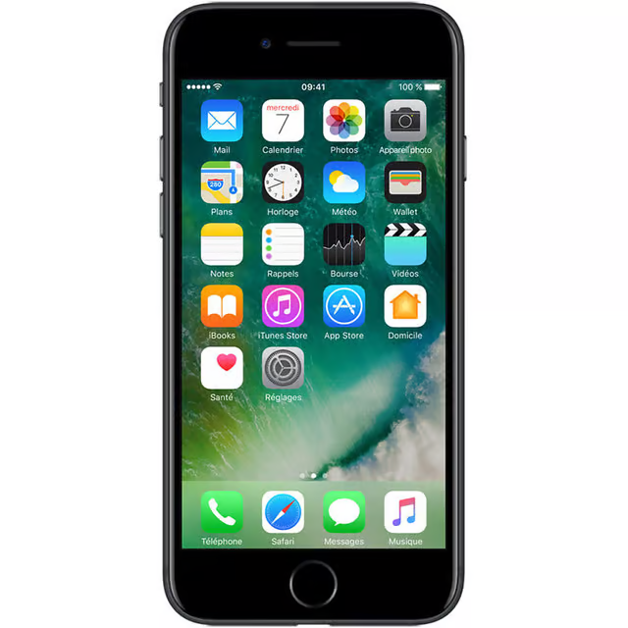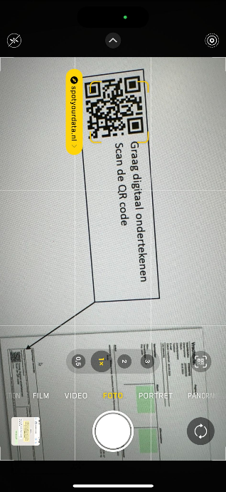

When the signing process is completed the chauffeur will see in the screen to which e-mail of the client the signed document will be send.

* Scan the below QR to test if the phone supports scanning QR codes from the camera app. If no link shows up in the screen you could download:

Android: QR & Barcode scanner

Apple: No app needed, camera app of Apple works

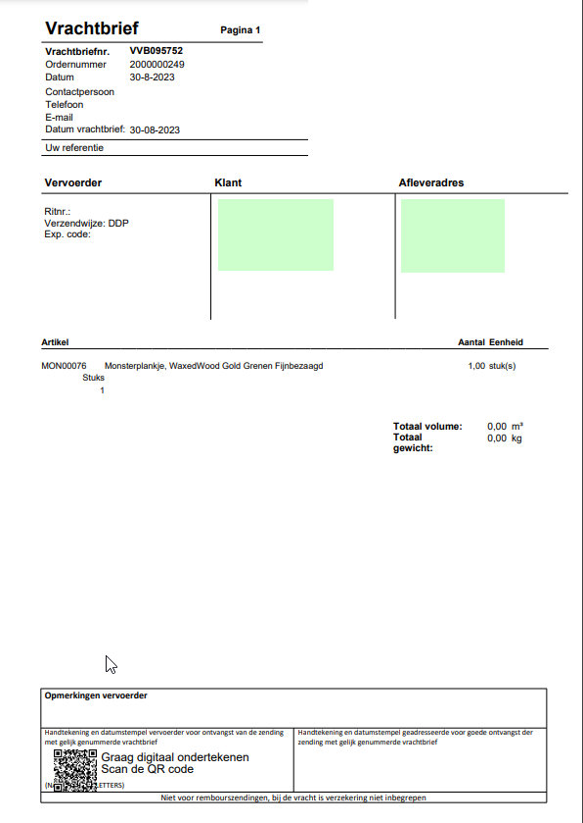

Sign this document digitally

Scan the QR code

